THE SINGLE TUFTED BRUSH

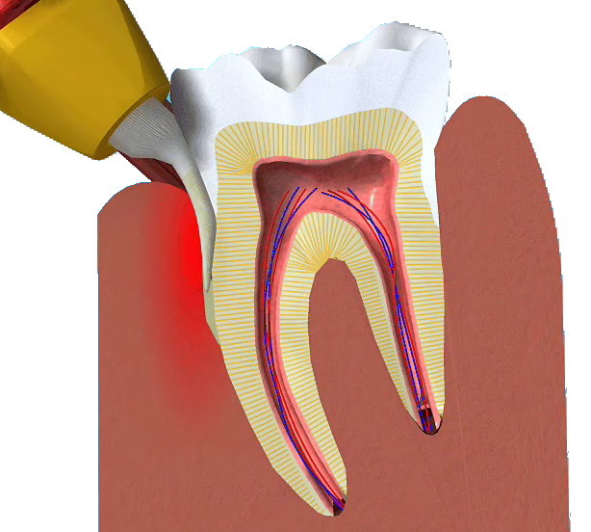

Q What is a single tufted brush?

A A single tufted brush is a toothbrush that consists of a small collection of specially configured brush filaments mounted on a standard toothbrush handle.

Q Where would I use a single tufted brush?

A The angle and configuration of the head makes them ideal for cleaning around implants, orthodontic appliances, crown and bridgework as well as difficult to reach areas.

Q Should I use a single tufted brush instead of my normal toothbrush?

A No, these brushes should be used to compliment your normal oral hygiene routine.

Q Why is my normal toothbrush not enough?

A A standard toothbrush is not able to reach the small and often difficult to access areas in most mouths. Any additional surfaces such as implants and orthodontic appliances require meticulous
plaque control, which is often more easily achieved with a single tufted brush.

Q How do I use a single tufted brush?

A Once the angle of the brush tip is established, the bristles should be placed against the surface to be cleaned and either:
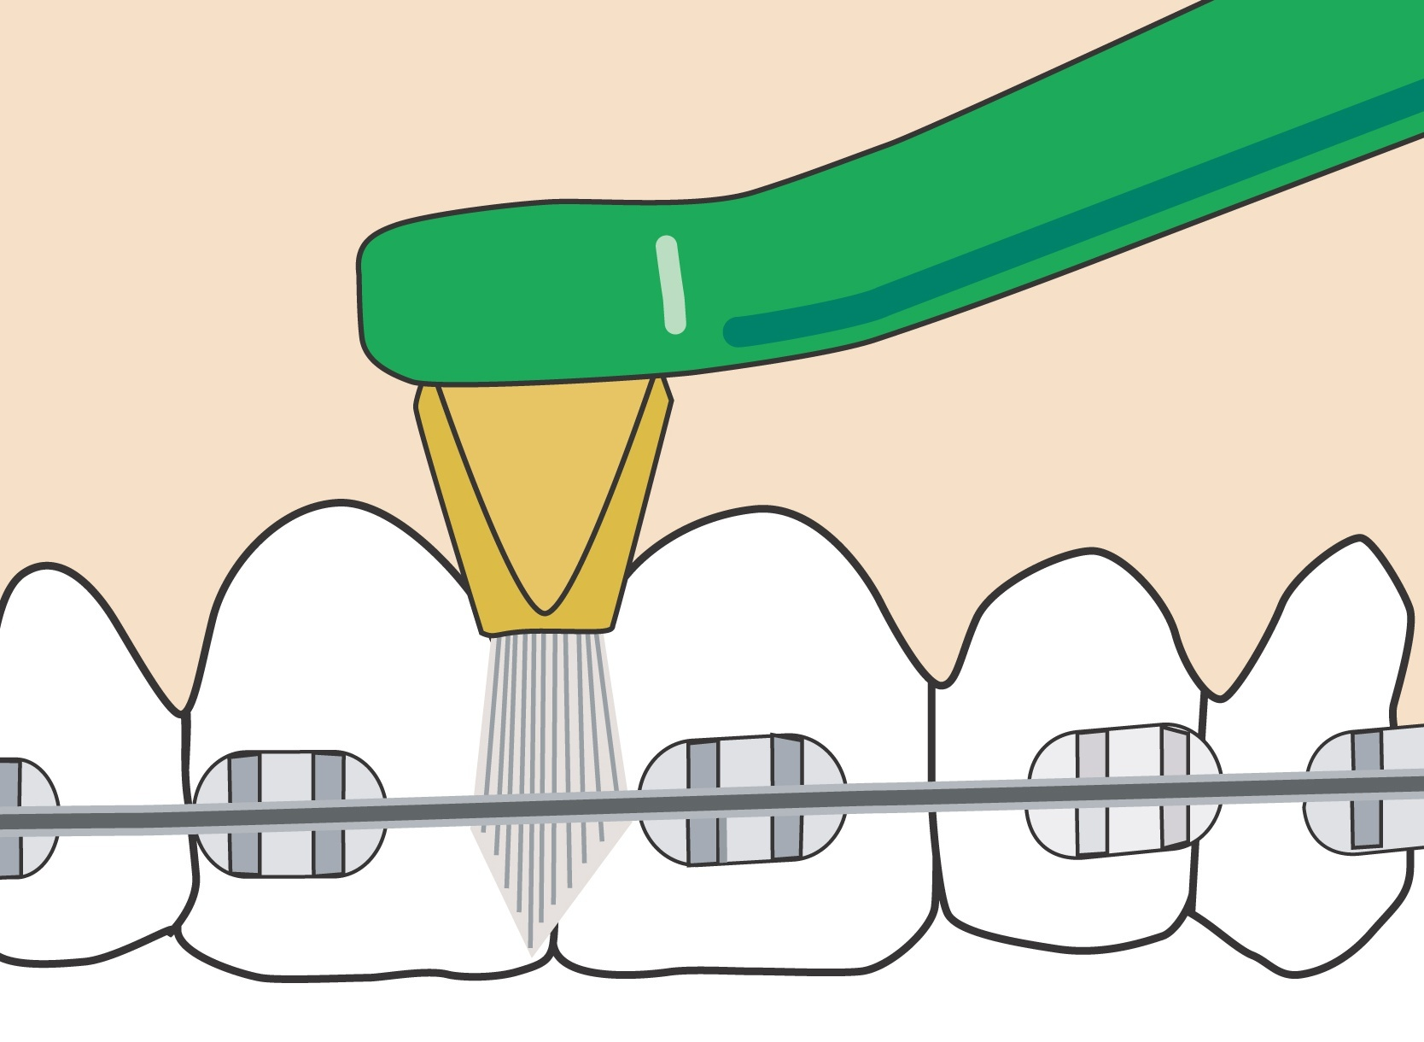

Splayed and agitated as in the case for cleaning around an orthodontic appliance.
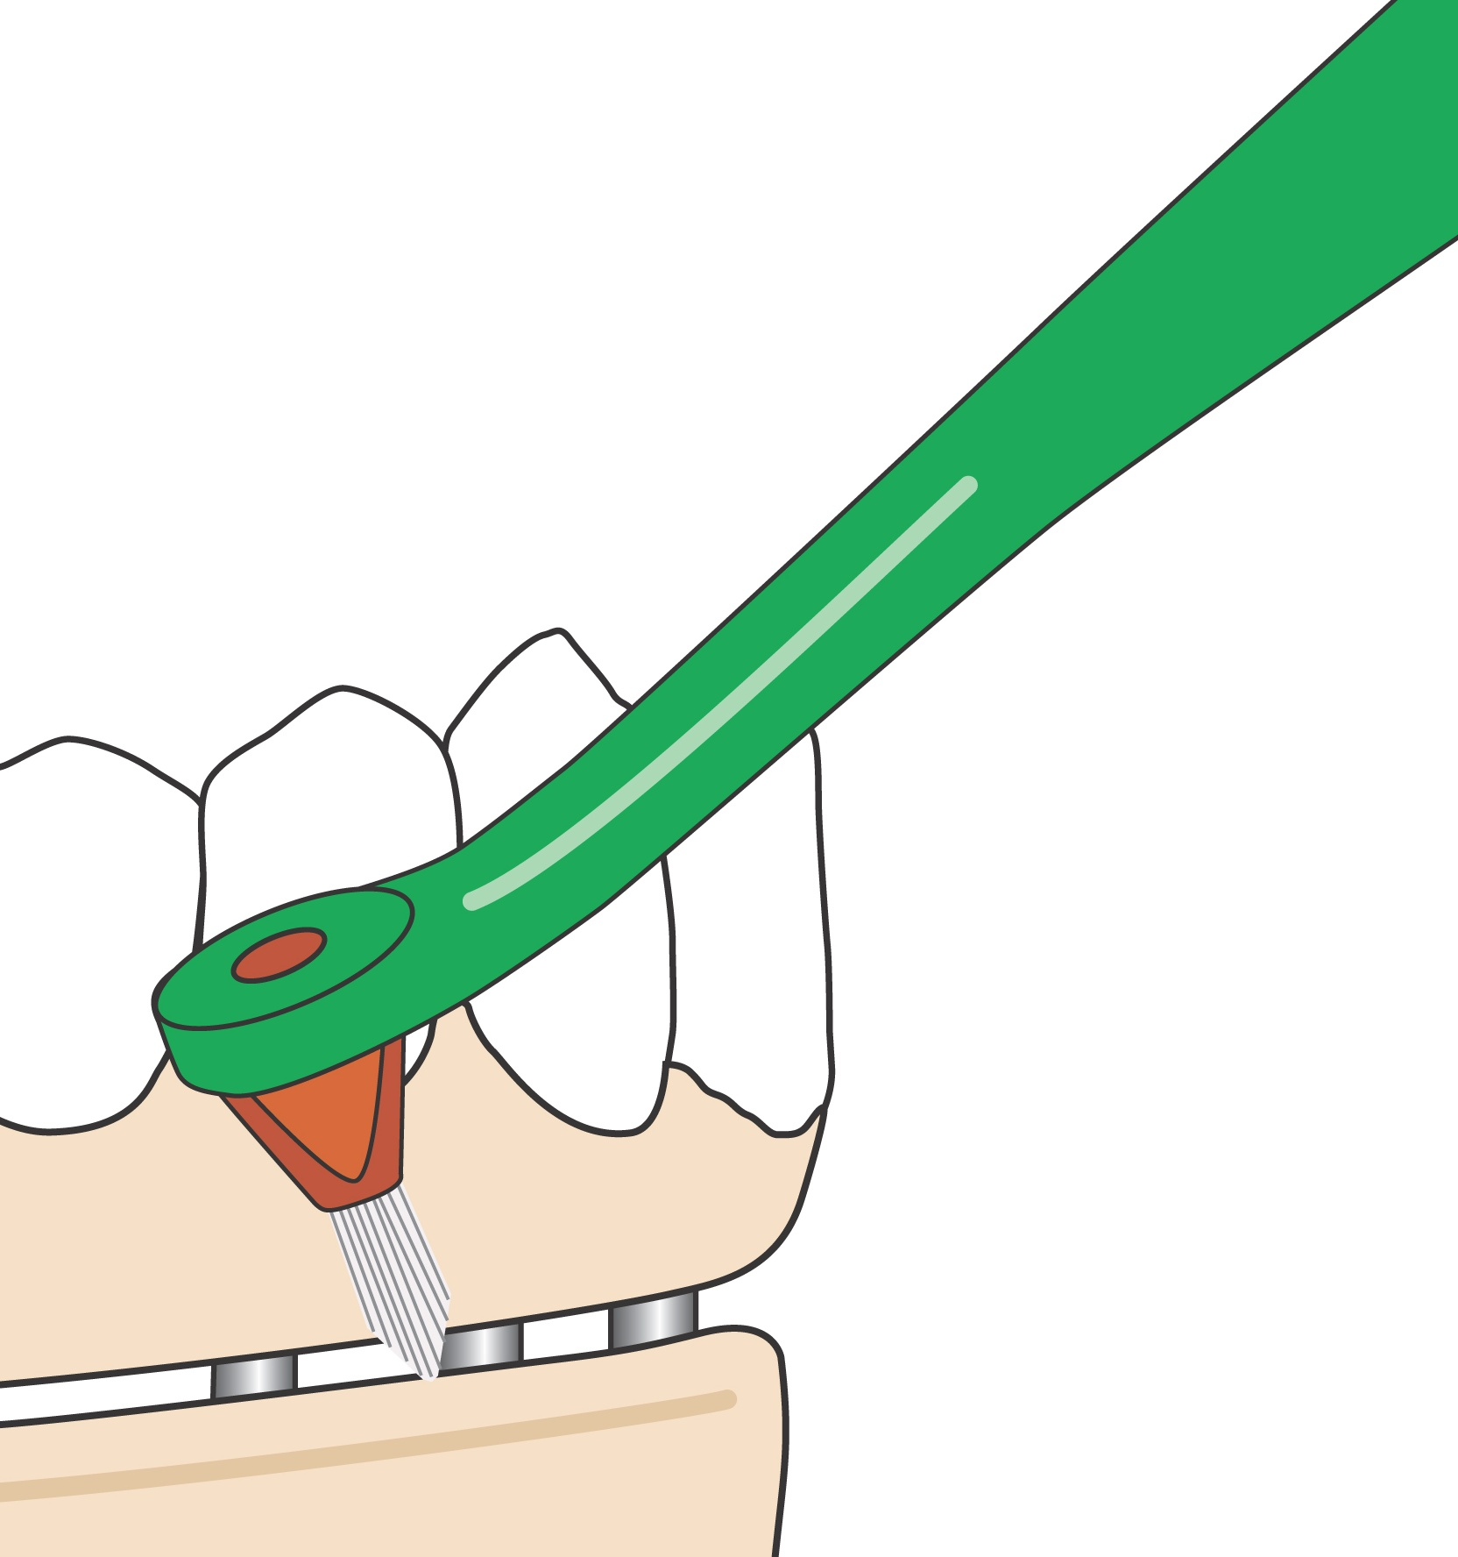

Splayed and moved with a small circular action for cleaning implant abutments.
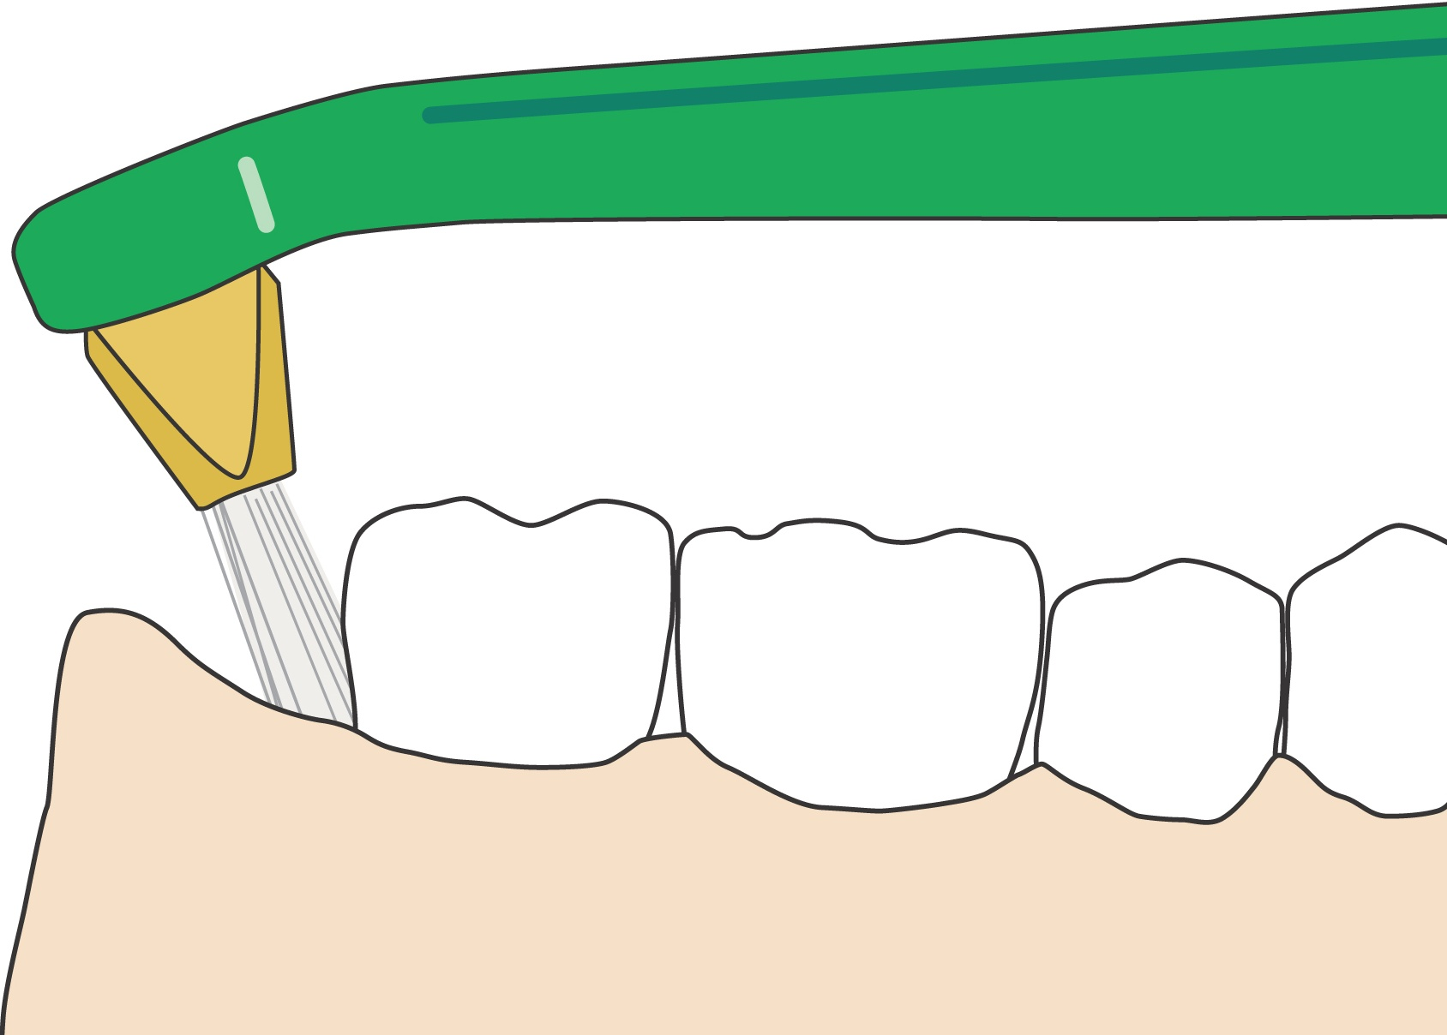

Splayed and swept along the gum line in the case of difficult to access back teeth.

Q How often should the single tufted brush be used?

A You need to clean thoroughly around appliances and prosthetic work at least once a day or as directed by your Dentist or Hygienist.

